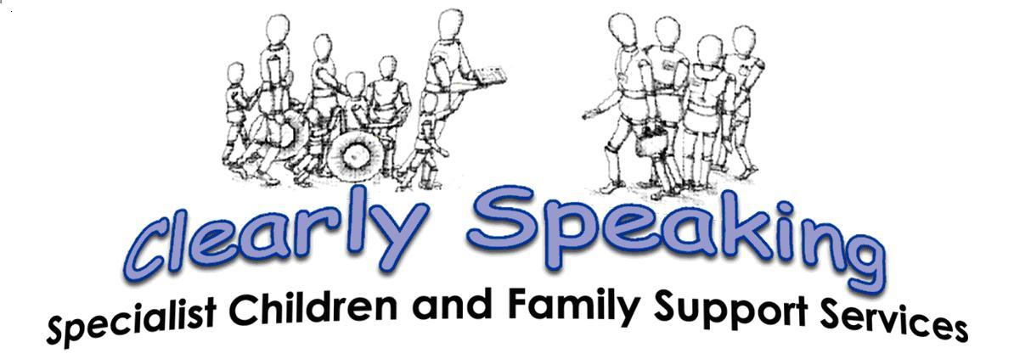
End of Year Report 2017- 2018
The Clearly Cool Clubs

Including the Views and Opinions from all those
Attending and supporting Clearly Cool Clubs.

Outline of Services.
It has been a very busy year this year which has brought with the great success, a great deal of upset and distress for our families as they work through the strain placed upon them from changes in the financial, physical and emotional support which has been further limited to them as the axe for austerity firmly hangs over their heads. It has been extremely difficult to divide our support sufficiently to ensure everyone felt they received the help and intervention they should have as their statutory support services have, in many cases, become even more remote and there is therefore a need for smaller charities and organisations working to support the needs of families who have members with special needs and disabilities, such as Clearly Speaking and the Clearly Cool Clubs, to step in an extend further help and support to all members of the family as is seen to be required.
It was a shock to hear that our direct contact with families, and the intervention we provided which included, support and advice as and when required, this includes the, drop in facilities, the help-line, the planned and invited events around Buckinghamshire and surrounding counties, and the clubs and activities, last year, allowed us to provide just under three thousand hours of contact and support. This was an amazing achievement and at a time when we experienced a drop in volunteers and the hours they were able to support, as their own situation caused them to need to step back from supporting others, and in some cases, causing them to leave us which were are very sad about. However, all are aware that they can come back and begin the formal registration process again, or access any of our clubs and activities or adult support groups, as is most appropriate for them.
The better news is that Sonny has worked really hard this year to contact a wide range of voluntary recruitment agencies to begin to help us to build a new team of volunteer, a team which towards the end of last year, has begun to support all the main clubs and activities we are offering to children, young people and to parents. The team are wonderful and responsive, making it easier to plan and arrange more for all children and young people. Many of the new team are able to make longer term commitment which is great news for those children and young people who rely on the stability and reassurance provided by familiar faces and voices. We now have a total of nine eleven regular volunteers who help and support all those who come to Clearly to receive help and support, or to enjoy the fun and activities available to a wide range of families. As we received and supported regular reliable volunteers to join the charity, we have been able to run more clubs and activities and to provide essential respite and club places to provide opportunities to build friendships, to develop social communication skills, to interact with others and to enjoy new or existing interests.
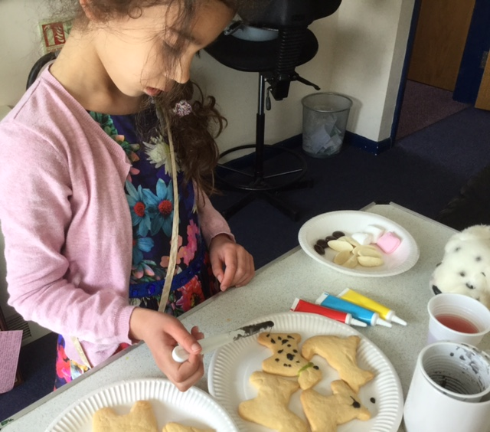
Summer fun, extending the youth clubs into the holidays, when we asked what children wanted to bake, the request for ‘one hundred and one Dalmatians,’ may not have been the best idea!
Junior and Senior Youth Clubs on Alternate Sundays, all Year.
The established clubs now running include: The Youth Clubs on alternative Sundays, from 10am to 12pm juniors are five to twelve years of age. All may be suspected of, or have a level of ASD/SCD, and associated difficulties, or are siblings of those who have difficulties which can cause more challenging behaviour within the home. Referrals come from a range of children and family agencies, parents and young people can self-refer or from school and G.Ps. From 1pm to 3.30pm, we have a senior club, for thirteen to nineteen year olds. This is a quiet, less frantic club which encourages young people to meet and make friends, have fun together, participate in games and activities they would not usually try and to continue to develop their social communication skills and they are supported to discuss and explore local and international issues which their peers may also be interested in or able to discuss within the range of environments they visit.
These clubs benefit from young volunteers who are over fourteen years of age and who also have a range of specisl needs and disabilities which, through their support through the clubs and support provided, has built confidence and the skills needed to understand how to help and support others. This is a huge achievement and we are greatly proud of all the young volunteers who are working with us.

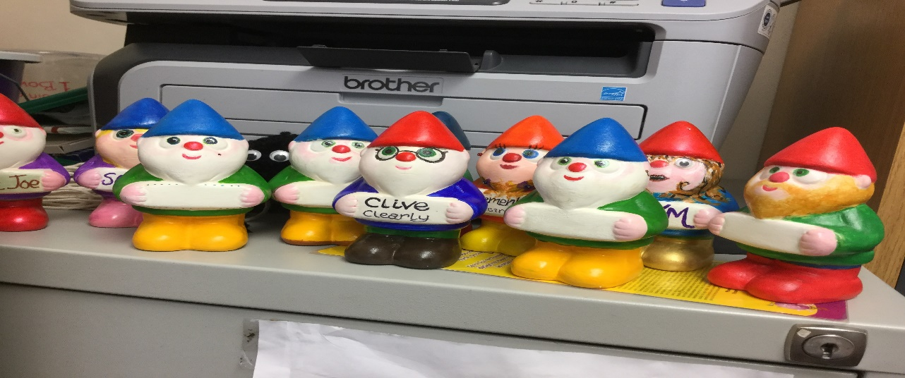
Our summer project was, gnomes, the children loved planting them around the garden. We were able to talk about personalities and how they may make friends etc. Great fun for everyone.
Due to the needs of all those attending and to ensure we are able to provide the care and support needed for children who regularly suffer fits, and those who need closer supervision but who still welcome discrete support so they can make friends, the numbers attending junior clubs is kept low. We need to work to support the higher support needs of some children in a way of which does not highlight difficulties, but rather, we work to discretely develop strengths and every child’s ability to play with peers and make new, positive friendships. This can affect our ability to cover the running costs of sessions despite the good-will of parents when most free pay the £3.00 cost of sessions. Due to the hardship many families are now suffering, this year we have been asked for a much greater amount of concessions than has ever been the case. We have been able to run thanks to the fund raising families have supported over the year.
OH No, pretending we are injured! Great acting with a mod-rock for a plastered arm.
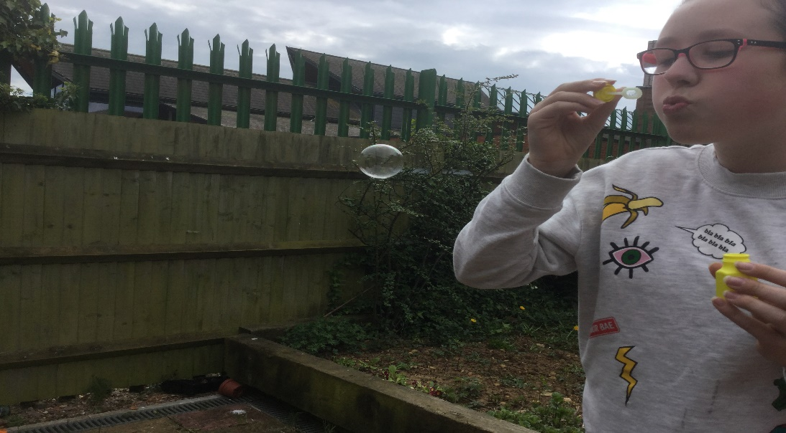
Enjoying the garden in peace. (Girl’s Group)
Girl’s Group.
This year we began the ‘girl’s group’, a group for those who identify as female and are between ten and sixteen years of age, who are suspected of being on the Autistic Spectrum or who have a range of Social Communication Skills. This was well attended at the start of the year but as we had to change the evening we run, the numbers have fallen away. This club is wonderful and allows us to check the girls are safe, we have done quite some work on teaching about safety on line, and in particular, safety in regard to who you allow to register on your phone, especially smart phones which can also link to other devices within the home.
These Wednesday evening sessions from 3.30pm – 6pm, at the Buckingham Youth Centre and Clearly Speaking, has also given us the opportunity to cook with the girls, an activity they have really enjoyed, we also have lots of crafts and time to play with toys, a wide range of games and within a range of comfortable developmental levels and including a wide range of interests. We have really enjoyed getting to know the girls and hope they have benefitted from this safe and relaxing environment. We have lots of places left and have a range of registered and trained staff and volunteers available to work with them.
It families are interested in their children attending the ‘Girl’s group’, all are welcome, we ask that as usual you get in touch with the centre, and allow Janet to assess those wanting to register with the group so she can make sure the right level of care and support is in place, and that all activities are adapted to ensure they are accessible to everyone attending. Please remember that every effort is made to ensure access is open to as many issues of specisl needs and disabilities as possible. The building does have a lift enabling those, such as Janet, who use a wheelchair are also able to come along. Please help the charity to help you, every effort will be made to ensure clubs are in place to help and support those who need them. As we have been working so hard to build these new clubs and resources, we want to make sure they are suitable for as many children and young people as possible, this may include changing the evening of this club if those makes access better for everyone.

Dungeons and Dragons.
We have another new group, this being the alternative Saturday Dungeons and Dragons club which is steadily increasing in members. This has been wonderful to participate within. This year the group has been working with Ben who is recording the benefits of working with young people fourteen to nineteen years of age, with a keen interest in the ‘role playing game of Dungeons and Dragons’. Young volunteer Aydin, has taken on the role of Dungeon Master, and is able to take all the members through perilous journeys where the characters work together, when they are not cursed or controlled by the dark side, and find their way to safety.
The group is for those suspected of having, or those who have a diagnosis of autistic spectrum disorder and, or associated difficulties. By working within this mixed gender group, young people develop their speech and social communication skills and learn the key and very difficult skills of listening and cooperation. The young people stay for lunch and have thirty minutes at the end of the session to chat and catch up with each other about their week, as well as before they head off home or are collected by parents.
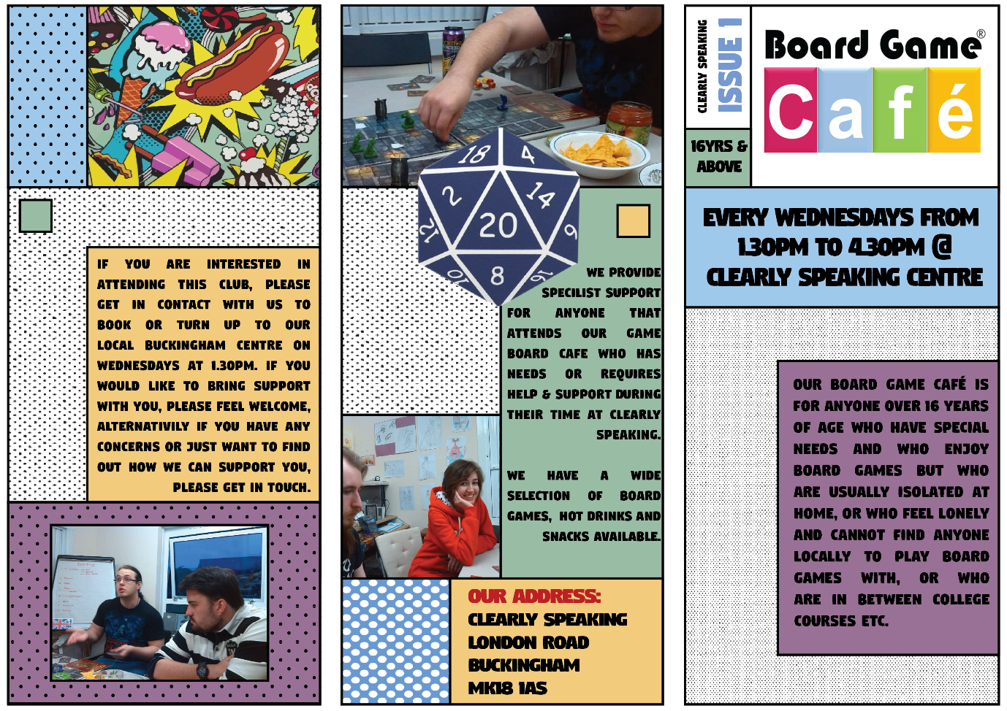
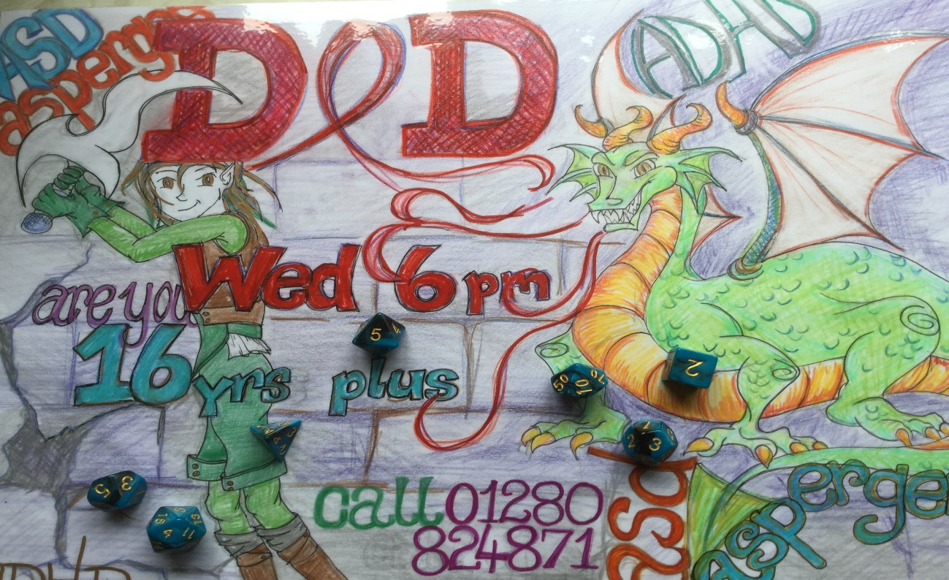
A poster designed by a member of the group. James has some amazing images (some seen below), he is happy to share with new members. The group used to be on a Wednesday evening until we were asked to change this by the group, Saturday 11am – 3pm gives time for a full adventure.
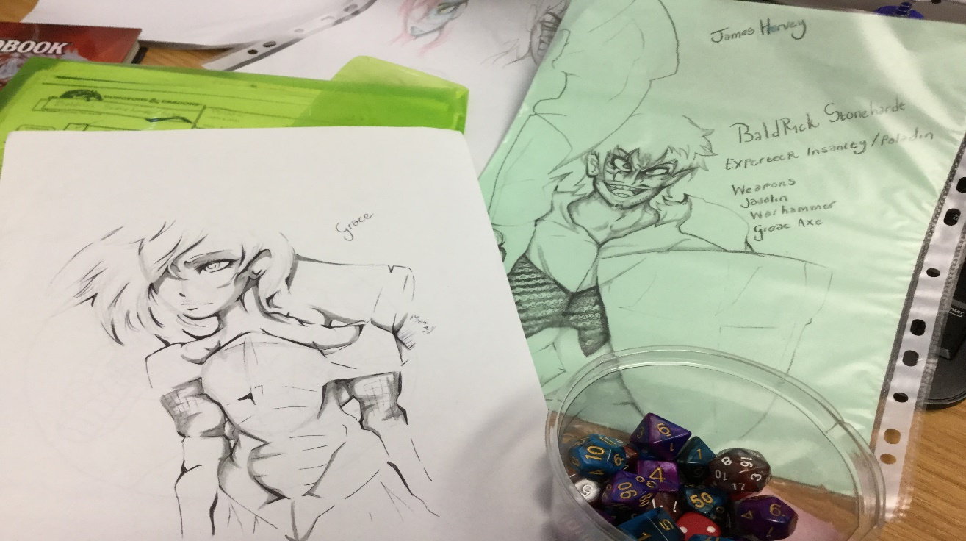
Our hope is to learn more from the research carried out by Ben an amateur film maker interested in the benefit of teaching social communication skills through the playing of a fantasy game which often requires all to work together. We look forward to sharing his thoughts and ideas on the ‘Clearly’ website when his short film is complete. Thank you to everyone who has participated in this research and helping Ben to complete his advanced degree.

Janet has always looked for new and inovative ways of supporting those with children and young people who have communication difficulties an social skills delay or developmental difficulties, to discretely learn these skills whilst they are provided with the opportunity to feel included, to make friends and to feel like this is ‘ well, just good fun’. Janet has devloped this communication program which runs across all our clubs and activties throughout the twenty five years she has worked to ensure all children and young people have the opportun ity to achieve their true potential. We are very gretaful to have the opportunity for someone new to have a look at a selective portion of this work and to hear his views of the success of this program.
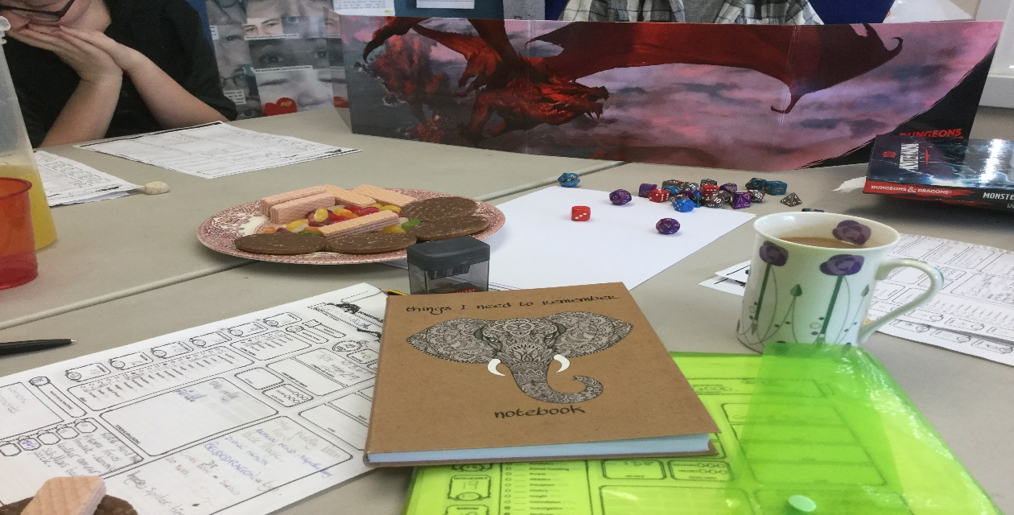

Cookery for the over 16yr olds.
This year we set up our first soup kitchen and have been working with the over sixteen year olds who need to develop their independence skills. They have been learning to prepare fresh foods and cook a healthy hot meal. They have done this by cooking together on a Wednesday afternoon not only for themselves, socialising as food finished cooking, and as they prepared food. They have been taught safe knife skills, how to use the oven and stove safely and what a portion should look like. They have also cooked extra to share with other young people who visit the youth centre, and Clearly Speaking, and who we know not to be having a hot meal each day. Food is put into the large fridge freezer Clearly Speaking donated to the Youth Centre to be able to share with ‘Clearly’ as they required. This can then be given out by the youth worker, ‘Clearly’ and other children and family groups working from the Youth Centre. We have secured the support of Fair-Share a local company which collects excess food with a short life from super markets, and shares it with groups like ‘Clearly’ so we can continue to feed those who need it most. We are hoping to secure local partnership funders to continue this work next year.

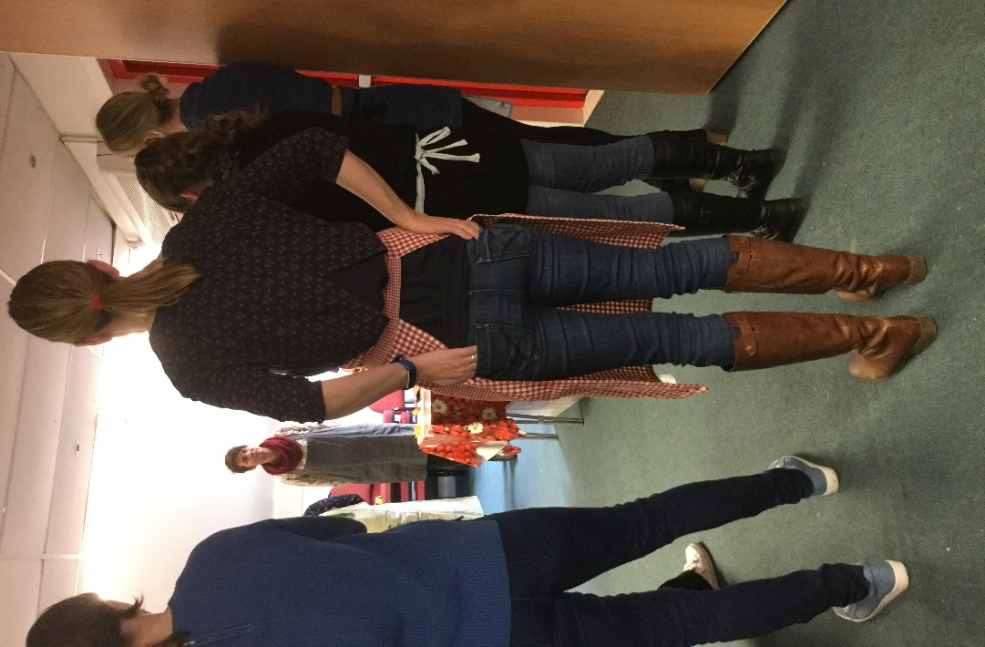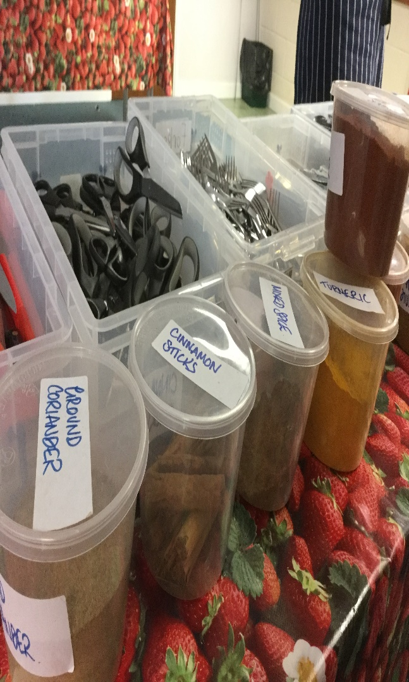
Janet from Clearly and Katie from the Youth Centre attended a national cooking skills course called Lets Cook. The aim of the course is to ensure those teaching and demonstrating cooking skills do so to a high quality and in a safe way. Both will work together to encourage much more cooking among young people in Buckingham.
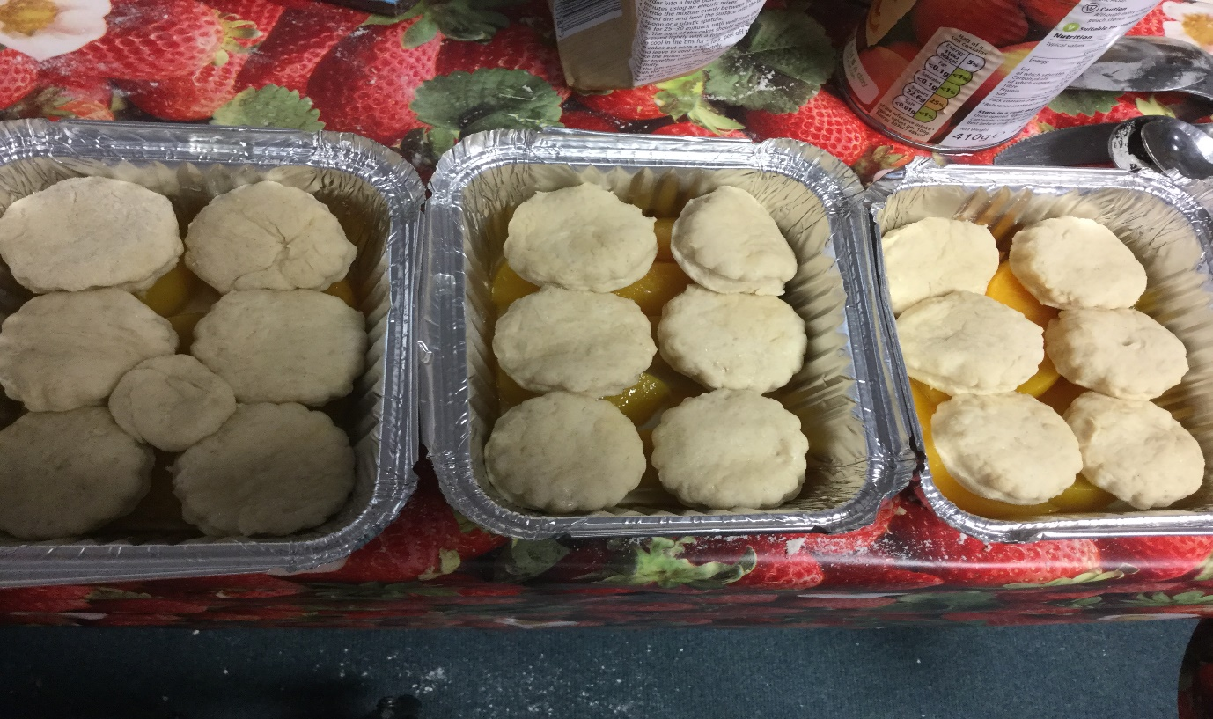
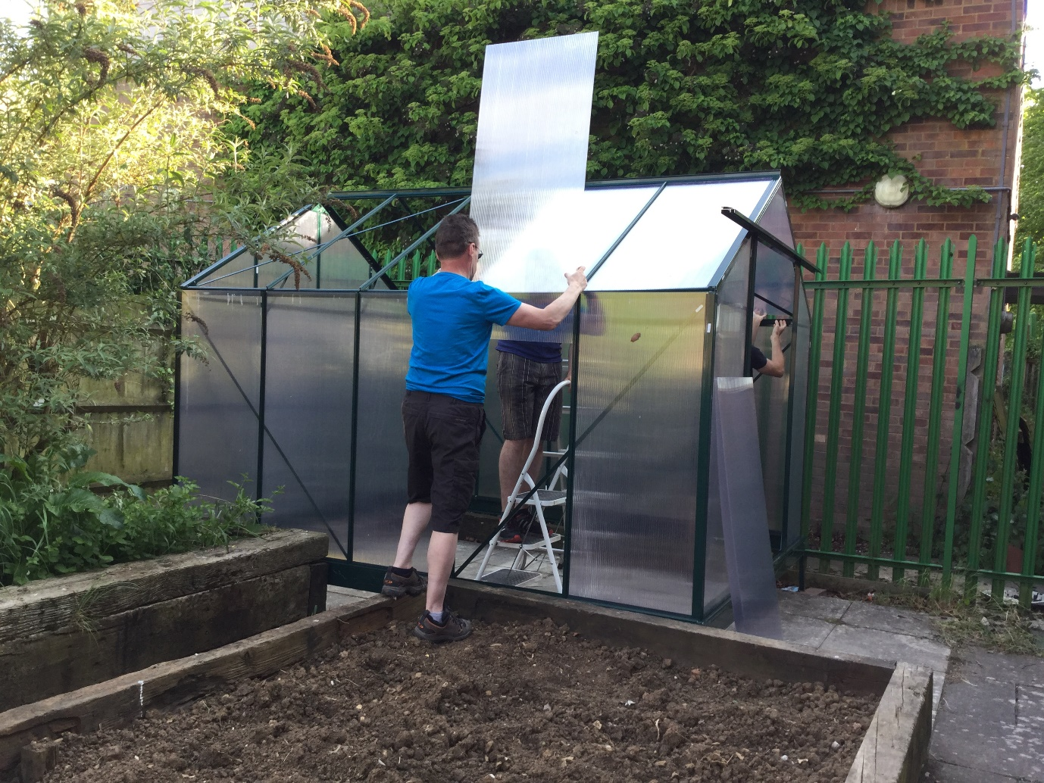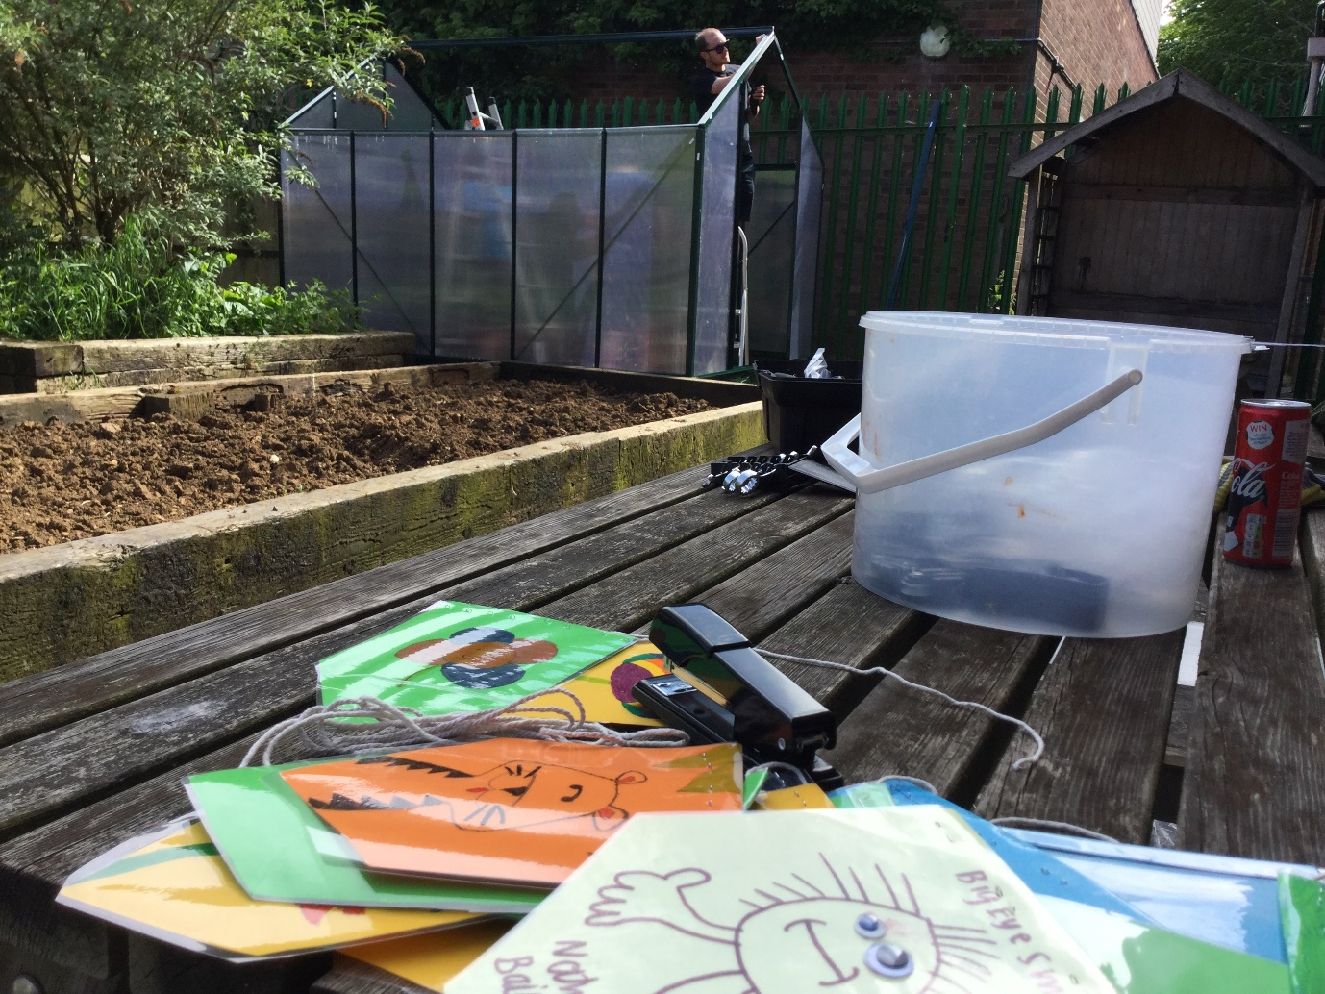
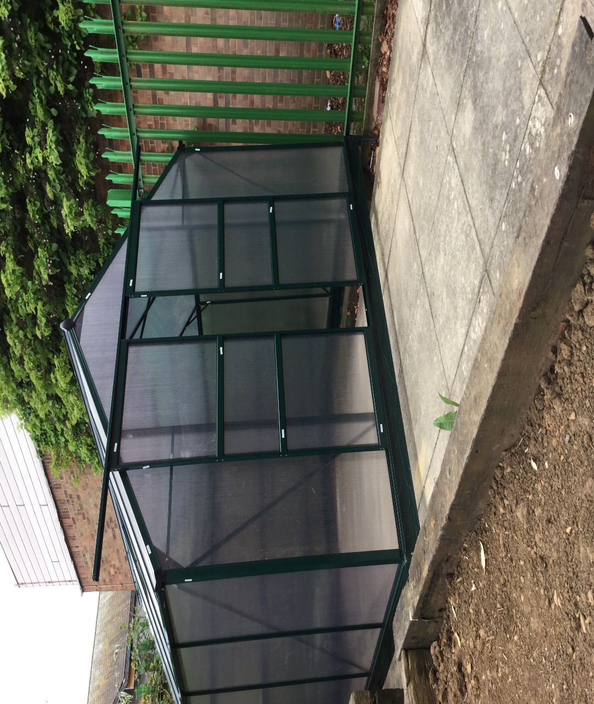
We are running our garden project which helps to feed in to the cooking project and we were really pleased to receive support from Santander who came to put up the long awaited greenhouse which now stands in the garden and has begun to grow the vegetables filling the garden which we are working together on with the Youth Centre. This new friendship between the two charities on the site has really benefitted all children and young people. Our time in the Youth Centre has increased allowing us to add to their funding for the site and we hope to do more of this is the future.
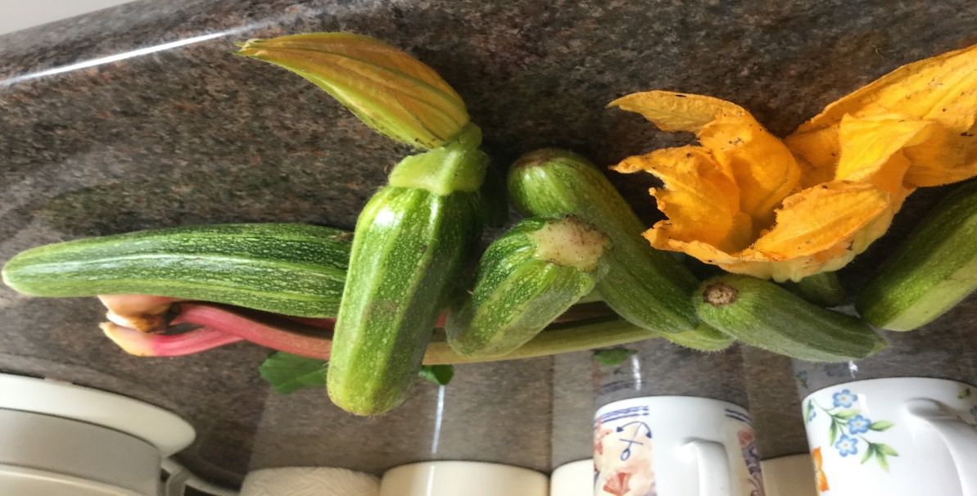
Last year’s crop of summer vegetables, heled to keep fresh food available for soups, available for anyone who needs hot soup on Wednesday nights. The new fridge freezer allow us to store food safely for longer and to reach more families locally.
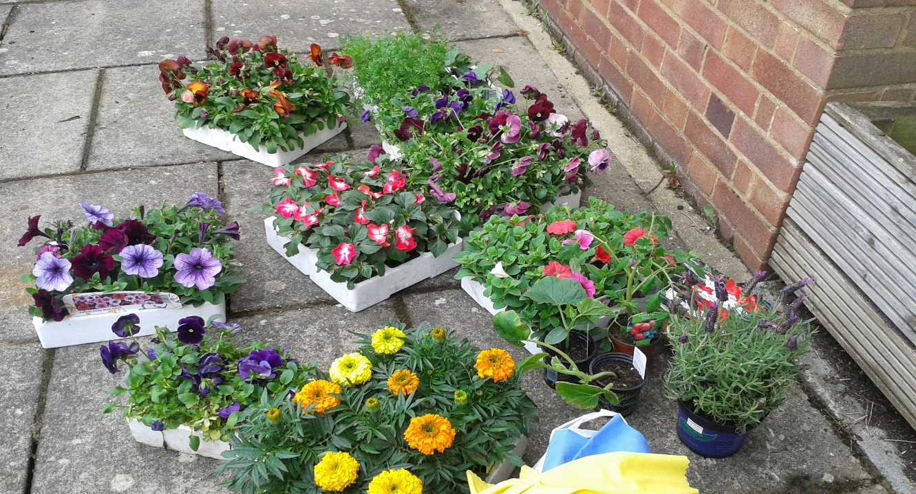
Donated flowers to help the project along. Thank you to Janie Garlic for her help to get everything planted out, adding colour to the garden.
The garden is so nice and peaceful and is being cared for by all clubs on site, we hope to lead in the projects as we are on site most days and have a further three new volunteers who wish to begin our new club which will meet twice a week to keep in top of the weeds and ensure the garden is as relaxing and safe as possible but also as productive as it can now be all year round.
We have the opportunity to grow under cover now and wish to set up two new associated clubs to encourage new members and adults who may have been missed out in the past. We still need lots of help and funds for the work we need to do to ensure this project works well. But here are some photos to show the very start of the project.
School holidays have been supported with our usual clubs running. Keeping the routine of our members. We also offered the range of clubs which worked last year, the sensory outdoor space which the younger children really enjoyed. We also met up at the cinema and went bowling in the summer break following the requests made by members attending clubs and activities. Other activities which they requested at the ends of their clubs included:
- Extra Dungeons and Dragons days please – three of these took place and a total of 11 young people enjoyed them with three visiting young adults. Both Aydin and Janet took the lead in playing the Dungeon Master and the players are now vary wary of Janet’s ‘oh so cute looking visitors to the journey’! This inevitably referred to nasty disguised menaces who tried to pick off the travellers one by one, but, didn’t actually manage. Aydin’s planned journeys were also very challenging, with the groups of friends often made to turn on each other and then to need to pull together again, phew! It’s all pretty intense.
- Sunday Clubs continued through the summer holidays and bookings were taken before the children broke up for summer. This helped with planning, when the majority of the children were away, we ran a drop in session in the week instead.
- We ran six craft, stitch and chill sessions for young people and parents who wanted to learn how to knit and sew. Small projects were run where these skills also included, rug making and jewellery making. A range of over ten years olds were welcome and time with mum and son, or daughter or dad and daughter or son worked well, we asked for volunteers to come in and help with the children who would benefit from an extra pair of hands. This was lovely, the groups chatted and relaxed together. That you to parents who agreed to donate home-made cakes and treats. We have been asked to run these again in the future.
- We ran two sports sessions teaching basic skills after booking the hall in the youth centre. We invited all local groups but this was not so well attended by those outside of Clearly Cool Clubs. We have agreed to look at which projects we can book for next year and to improve our relationship with youth clubs to encourage better integration. Our members did enjoy the games although the weather was extremely hot, we set up the paddling pools and the children sat with feet in the water to cool down.
- Our seniors asked for a digital games day and this was run during the Easter break. We had a good attendance was were able to use a range of digital game systems for the involvement of nine young people and two visitors who had previously not been known to us. The day was very enjoyable with young people moving round the games and working to support each other to get through tougher games.
- Finally we ran the drop in sessions for parents and young people and offered support to those who have been struggling with mental health difficulties and low mood. The sessions allowed anyone who needed a friendly, calm and confidential chat to feel safe and share the issues which continue to cause then to feel distressed and uncomfortable. These sessions are offered in the weeks whenever possible as so many adults and young people with high functioning disorders, which include high anxiety levels, no longer meet the criterion for adult’s mental health services. We work to avoid them falling into crisis again through the provision of support and a safe person to speak to, a person who will ask for help and support should they feel that there is a risk of harm or if they are entering crisis as their needs are becoming more overwhelming and unmanageable. The feedback we have from those who used this support service has been very positive, with three families stating that the intervention prevented them from re-entering the mental health system and allowing them to have a much fuller and relaxing summer break.

A huge thank you to organisations and new fund raisers.
We have been working with additional organisations this year and this we hope to continue into next year. It has been problematic for Janet to get out to new families and we have been inviting them into Clearly Speaking to have their assessments carried out and for their registration for clubs and activities to be discussed and agreed. Some families have stated that this caused them some hardships and that it delayed their access to our services. We will work together to try to find a solution for this issue however, Janet’s condition is degenerative and her need for a wheelchair permanently will not cause some issues in regard to mobility and her energy levels. Our aim is to continue to work with our volunteers and to train up those who are more confident and to ensure training allows them to take on some of the more remote registration in future. This will always be with the full agreement with parents, and the person being supported. Further funding will be needed to ensure this work is supported, with travel being funded and where appropriate, the intervention of specialists can be supported by ‘Clearly’.
On a Monday and Friday afternoon Janet and volunteers run a drop in facility for adults and front line profesionals who are working with children with specisl needs and disabilities. This is for the opportunity to have general questions answered or for Janet to set up a private time for a meeting if it is a little more sensitive. This is also an opportunity to learn more about how to knit or sew or crochet together with other parents, teachers etc. many questions asked by parents are helpful to all families, e.g. how do I apply for Disability Living Allowance. Janey helped seven families secure access to this helpful fund which is available for children and young peole who clearly need additioal support and intervention to have their needs met and to avoid them being treated less favourably than their siblings and peers due to their disability.
The rules have changed significantly and it is much harder to get the help and support so many children with disabilities need. However, our success in helping families demonstrates Janet’s skill and commitment to all those families who come to Clearly Cool Clubs and Clearly Speaking. If this is not likley to be awarded or if it is not considered to be apporpriate for this benefit to be applied for Janet will advise parents of this and let them know where they could go to get the help their children need. During these sessions, cute but very useful teddies designed by Janet have been produced, children can leave little notes in the heart shaped pocket on the chest of each teddy, to let them know there is a problem, or to help children communicate they they are struggling, a traffic light system can be used to enable parents to listen to their child, or to get help and support them quicker than may have been the case without these great little, individually designed teddies.
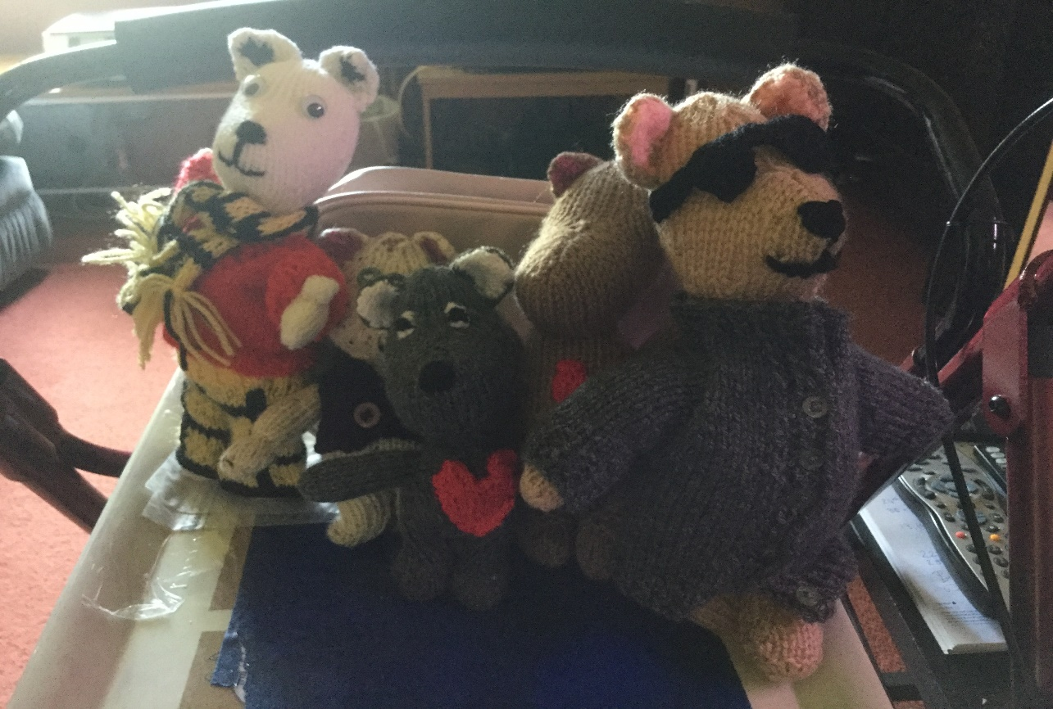
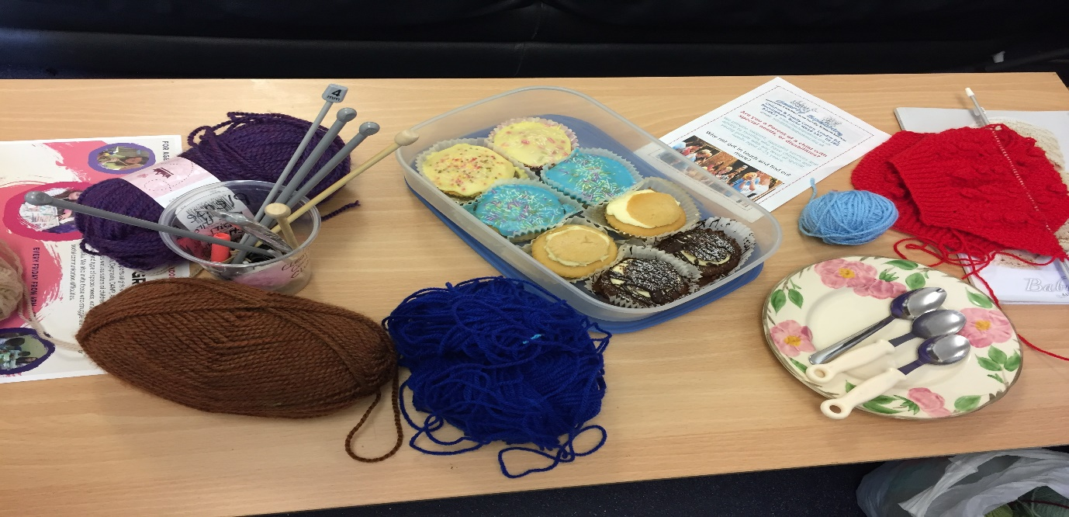
We also run a booked support service for parents and carers to ask for help and support. This year Janet managed to help to put in place five beneficial EHC Plans. Three of these were very complex cases which required a battle to gain the best understanding of the child’s needs and then to ensure everyone was on the right track when planning the support needed. As a result of the time and level of intervention and support needed for each case, we are limiting the number of cases being taken on. Janet and the volunteers at Clearly will always share good advice and their own experiences, but may not be able to take the lead in cases if we already have a high level to take through to a successful outcome for individual children. The clubs and activities which are partnership funded from a range of children and family services etc., help to support applications as it is possible to gain a true picture of children’s needs, their strengths and their weaknesses etc.
We were extremely fortunate again this year with so many amazing people who raised funds for Clearly Speaking and the Clearly Cool Clubs. We received out five thousand pounds from Buckingham County Council, essential funds to enable us to continue our specialist care and support to those who so clearly need it. We are fortunate that next year we should receive a partial grant which is conditional upon the completion of the work agreed to be completed, e.g. the running of the youth clubs and holiday schemes. This funding helps to provide us with some important stability.
We were also supported by Santander who raised some funding for us as well as their hands on support when children and young people were not on site. We ae extremely grateful for their ongoing help and support.
We were supported to raise some extra funds to ensure the greenhouse we bought was larger and so more inclusive, but also much safer as it is made of Perspex to avoid any serious injury should children find their way outside in the garden without an adult volunteer need them.
Parents coffee mornings from among other, Mrs and Mrs Das, helped to raise funds following their coffee mornings, wow, this was fantastic. This helped to fund the fridge freezer now based in the youth centre and benefitting all groups using the centre. They also helped to fund additional toys for the youngest members of the clubs we run.
A huge thank you to Janie Garlic and Olivia who donated so many wonderful toys for the small children. These have all been very well used and are greatly played with during the busy week at the centre.
The sale of our handmade cards, uniquely designed by Janet and the children and young people within the clubs at the centre, also made a tidy sum which has paid for new equipment and art materials. They are available in reception and cover a wide range of events.
We have been asked by young people to please run a workshop with rarer crafts from a range of counties if possible who can demonstrate designs and techniques for making cares and crafts to sell. We would like to do this next year when we have more time to plan and arrange this.
We have a huge thank you in the window of Clearly Speaking, passing on our thanks to all those who have supported and raised funds over the last year. A huge thank you to everyone who donated their time which is also important. Please get in touch if you have any ideas to share with us and if you are able to support us to carry out fun and inclusive events and activities.

What Next?
We continue to advertise for trustees and volunteers so that we can continue to run a wide range of clubs and activities. Children and young people would like u to update out games systems as we are no so out of date that it is putting people off the clubs or so we are informed! We will need to raise further funds.
We need new equipment for the essential cooking project, do you have any good quality plastic bowls, scales, peelers, tin openers, sharp knives pans of a larger size etc please, plus portable cooking stoves etc, anything which we are able to use to cook outdoors and indoors with young people and adults. We also would love to hear from local chefs and cooks to come and donate one sessions of cooking a particular skill, e.g. a special bread, pizza bases and tomato sauce, national dishes suitable for a wide range of pallets and dietary needs. Please pic k up the phone and get in touch.
We need to build on our gardening skills, and we would love to welcome anyone who has a love of organic gardening. We need donations of flowers and vegetables please so we can make this a wonderful relaxing sensory and productive space for the whole community. Again, please get in touch if you feel you can help.
We have fund raising planned with Buckingham Youth Centre next year but need help. Can you help us to secure great gifts and prizes for a raffle, a bingo night and a quiz night, if you feel able to help with any of the funding efforts and have the time to donate, please call us or get in touch by email?
We need a safe and good size trampoline for our Autistic children and for whoever just loves to bounce, we need £250.00 for a safe surround etc. This is a priority for next year and would love to have this in place by next summer break please. If you have any sensory play, secure sandpit, with a cover to keep wildlife out, and raised if possible so it is accessible to all. Plus water play troughs and runs, are you updating or getting rid of your child’s out-grown toys, please can you donate them to our charity to provide lots of fun and safe play for our members?
Finally, a Huge thanks to our dedicated, hard-working volunteers.
Thank you to the amazing Hitchen family. Thank you to Jane, Tom and Leanne without who so many of our clubs would not be able to run so smoothly. They have been at the centre on time most weekends and in the week to ensure we are ready to meet and greet out parents and their children ready for fun. We really appreciate their help and support to keep everything running.
Thank you to all our regular volunteers, Michelle, Aydin, Jo, Serena, Laura, Kirsty, and all those who step in when needed including; Mrs Brown, Mrs Farley, Dawn, Kingsley and Katie. We look forward to working with you during the year ahead. Our aim is to get everyone through their first aid, Safeguarding Training and Food and Hygiene when appropriate. We also want to continue with our extensive internal training and support to all our volunteers and we look forward to welcoming more volunteers in the near future.
Next year we will be sharing our success and offering larger open training workshops where parents and carers as well as front line professionals such as social workers and teachers, are able to come and hear how we achieve the success we have over the many years we have been providing this specialist, discrete support and intervention. Please watch our website to find out more.

Please share this with those who may be helped by the intervention and support described within this report. Thank you.

Every Year we gather feedback from everyone who accesses Clearly Speaking.
2017 - 2018

Feedback from our Members.
At Clearly Speaking and the Clearly Cool Clubs, we record the views and opinions of our members whenever there is an appropriate opportunity to do so. This feedback from all members, is essential to the running of our organisation, and it ensures that we are able to continue to meet the needs of all those who come to us for help and support.
Members are considered to be all those who register with our organisation, all children and young people are recorded with Clearly Speaking, and, or, the Clearly Cool Clubs, have a detailed registration form informing the organisation, and those volunteers providing direct care and support, of any needs they have which may need some additional intervention. It is made clear that this information will be stored carefully and when not in use, e.g. their child is attending a youth club so the form is safely stored in the blue box-file, on the counter which is manned continuously by senior team members and club leaders, it is locked away in the centre’s filing cabinet away from the sight of any third person.

Children from our junior clubs and activities told us the following:
- I like the clubs because I can make friends better. It’s not too loud like lots of other clubs I went to. I am going up to the seniors soon and the people who help and support me have gone to the club with me so I am not scared, I am having another friend who I know because she is in juniors as well, well, she is moving to seniors too so we will know each other. I wish there were more Clearly Clubs near to my home. (13yr old young lady from Waddesdon, Bucks)
- I didn’t like youth club at first because it was more sensible, but when everyone came and started playing a game I liked, you know, everyone even the volunteers helping, then I knew it was going to be fun, and it is!
(Young man from Aylesbury 11yrs of age)
- I was allowed to bring my big sister so I could try girl’s group. When I came I saw that I knew someone anyway, and I loved the crafts, then I didn’t need her any more. I really liked the girl’s group but the day had to change so I can’t get there anymore. Please can we have more girl’s group or change the day again so I can come back.
- I don’t always like it when only a few people turn up for club. I really like the activities but, we can’t do the bigger games like parachute games when less people come. It’s a bit boring when we can’t play football as well. (An eleven year old male)
- I think it’s great that we have volunteers who are men and women and we have young people not much older than me, you know, like by older brother, he is fifteen, I think they are his age. They join in and make it better when there are not so many members at club! (a young man of twelve years old)
- I want to do more cooking so come on, let younger people do more cooking too. (Nine year old girl).
- When I was having a really hard time, I felt so angry, so mad, but nobody get cross with me, I just didn’t want to talk about it, so we didn’t. Now, I am talking to one of the volunteers who has supported me for four months. It was when I was ready, no pressure. It is really helping me. (Senior club member, sixteen year old female).
- Here, (at Clearly), nobody judges you if you have a bad week and you fall out with anyone. They help you to sort it out and just make sure you feel welcome when you are ready. At school I have no friends and the teachers say it’s because I am moody and ‘not easy for anyone to like’! This makes it worse, not better. Sometimes I feel really sad and like cutting myself, but there is so much going on at Clearly that I can usually ask mum to drop me over, then I can try and talk to someone rather than having to hurt myself. Thanks. (Seventeen year old male member of Clearly).
- You know what, I don’t like clubs and my mum forced me to come to Clearly. She said it’s just a club, nobody will care that you are different, yeah right I thought!! But you know what, because everyone has things that make them different, actually nobody does care or notice that I am different. Oh, and I am really glad my mum forced me because I have been coming for three years now, ha! (I am thirteen and love Clearly, I don’t care who knows it)
- I have friends, I love it, I have friends for the first time and it’s great. I keep telling other people about Clearly but I am a bit sad that they don’t come and have a go too. (seven year old girl from Buckingham)
- I wish there was more for older members, there is not really enough especially as we have finished school so have more time to kill. Please can we do more, say trading cards or gaming perhaps, I don’t really know but I would come more if there was more for us older members to do.

Parents told us:
- This is the only place my son will go to without a fight. He actually askes me every weekend, he will say, is it clearly this weekend, it helps him get through his difficult week at school. It’s been really nice to see how much he enjoys coming.
- It was a difficult time when we were trying to get her to come to clubs because we knew it would really help her with her communication, her speech and her social skills. But now, it’s great, she does enjoy coming and her speech and turn taking as well as her confidence is really improving, even school have said that they have noticed a difference in her confidence and her ability to participate in group work activities. Thank you to all the dedicated volunteers who help and support my daughter.
- I wanted to say a huge thank you to everyone at clubs because I really think you stopped me going insane. They made time for me at the start and, or the end of club sessions to listen to me, or, Janet would help me with advice and things to try and help my sons with. They just could not get on but now, it’s not always great, but I can at least help them to avoid the huge fights they had, and to make them feel safe and like they can speak to me or to volunteers at Clearly when they need or want to. Thank you, it has made a real difference to our family, all of us.
- My son loves coming but when it’s quiet because not many members have turned up, he is really sad and disappointed.
- Mr Son really struggled to make friends before he started come to Clearly. Now he is more confident and he does not get so upset when things go wrong in school. It has been nice to hear him asking to go out to his club and getting excited about who he will play with or spend time with. We also like the positive feelings he has about what he can do now, rather than what is hard for him and what he feels is unfair because he finds them difficult. The young volunteers are amazing, they really do provide positive role models for all children who go to clubs, and this is a really good idea.
- My daughter has made friends and feels like she is wanted at the clubs she is able to play comfortably without any teasing. I am so pleased that there are more recent clubs suitable for her needs and where she feels at home. Thank you Clearly Cool Clubs, we all really appreciate your help and support for the whole family.

Recorded from our Registers at the end of Club Sessions:
- I always come away feeling really good about helping at clubs. The kids get so much out of the clubs and really enjoy the range f crafts, games and fun available at each club. It’s a shame more children and young people don’t come along and take part in the clubs, some sessions can be quiet and this makes it harder for members to make friends and enjoy the sessions. We need at least twelve children to enable everyone to be able to join in with every activity. I am really enjoying my time with the organisation and hope to be able to continue after my exams.
- I have really liked coming to help out at Clearly, it has really helped me with my confidence and when I speak to my tutors about what I want to eventually do for work, I have said that I would like to work with children who have disabilities.
- It has been really good fun working with the children, they are all very different even though they all have the same diagnosis. It has been a real eye opener.
- I was afraid of people who have fits, like epilepsy. But the training we had, being so practical and with it being explained so clearly, means that I think I will be able to deal with everything now, I will not feel so helpless or useless. It’s a shame, more people do not get the chance to work with charities like ‘Clearly’, so we can all feel more at ease with people who have disabilities.

